**Report**

**CSE322 : Computer Networking Sessional  
Offline on ns2**

## 

## 

## 

## 

## **Date of Submission:** 31st January 2023

## **Submitted by:**

Muhammad Ehsanul Kader

1805067

L-3/T-2

CSE-B1

## Parameters:

**Wireless MAC:** 802.11

802.11 is a set of standards for wireless local area network (WLAN) communication. It provides the specifications for wireless transmission of data and is commonly referred to as Wi-Fi. It operates in either 2.4GHz or 5GHz frequency bands and is widely used in homes, offices, and public places for internet access.

**Routing Protocol:** DSR

Dynamic Source Routing (DSR) is a routing protocol for wireless ad hoc networks. It allows nodes in the network to dynamically discover a route to a destination and maintain it. DSR is a reactive routing protocol, meaning that a route is established only when necessary.

**Agent type:** TCP Tahoe

TCP Tahoe is a specific implementation of the Transmission Control Protocol (TCP), a protocol for reliable data transfer over the internet. It uses a congestion control algorithm known as "slow start" that adds more data to the transmission gradually until it detects network congestion. Compared to other TCP implementations like TCP Reno and TCP New Reno, TCP Tahoe has a simpler congestion control mechanism and reacts more conservatively to network congestion.

**Application:** Telnet

Telnet is used for remote access and management of network devices, servers, and applications. It provides a command-line interface for remote users to connect to and control these devices over the internet or a local network.

**Node Positioning:** Random

**Flow:** Random Source Destination

## 

## Graph generated from output data:

### With respect to Area Size:

Network Throughput:

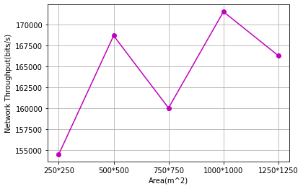

End-to-End Delay:

Packet Delivery Ratio:

Packet Drop Ratio:

With respect to Number of Nodes:

Network Throughput:

End-to-End Delay:

Packet Delivery Ratio:

Packet Drop Ratio:

With respect to Number of Flows:

Network Throughput:

End-to-End Delay:

Packet Delivery Ratio:

Packet Drop Ratio:

## Observation:

1. I was assigned to use Wireless MAC 802.15.4, however, it would sometimes result in negative throughput. For this reason, I conducted my tests using the 802.11 Wireless MAC instead.
2. As area increases-
3. Network Throughput doesn’t show any definite trend.
4. End to End delay increase.
5. Packet Delivery Ratio decreases.
6. Packet Drop Ratio increases.
7. As number of nodes increases-
8. Network Throughput doesn’t show any definite trend.
9. End to End delay increases but it drops again for 100 nodes.
10. Packet Delivery Ratio decreases but it rises again for 100 nodes.
11. Packet Drop Ratio increases but it drops again for 100 nodes.
12. As number of flows increases
13. Network Throughput increases.
14. End to End delay increases.
15. Packet Delivery Ratio decreases.
16. Packet Drop Ratio increases.